Task 1
- Create a new infobase and run it at a designer mode
- Create a catalog “CatalogWithCodePresentation”, with default presentation as code
- Create a catalog “CatalogWithCodeAndDescription”
- Create a document “WorkWithRefsAndPrimitiveTypes” with attributes:
  - CatalogWithCodePresentation, type CatalogRef.CatalogWithCodePresentation
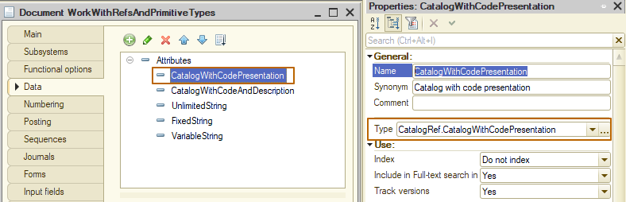
  - CatalogWithCodeAndDescription, type CatalogRef.CatalogWithCodeAndDescription
  - UnlimitedString, type String, max length = 0
  - FixedString, type String, max length = 50, string type = Fixed-length
  - VariableString, type String, max length = 50, string type = Variable-length
  - NonnegativeInteger, type Number, max length = 10, Nonnegative property has to be checked
  - Float, type Number, max length = 10, precision = 5
  - OnlyDate, type Date, date format = Date
  - OnlyTime, type Date, date format = Time
  - Boolean, type Boolean
- Run the infobase at an enterprise mode.
- Create 1 data object at catalog “Catalog with code presentation” and 1 data object at catalog “CatalogWithCodeAndDescription” with a description “Test”
- Create a data object at document “Work with refs and primitive types”, save it.
- Fill the attributes with referential types and compare their description. You will see that with the same data they look different at form fields.
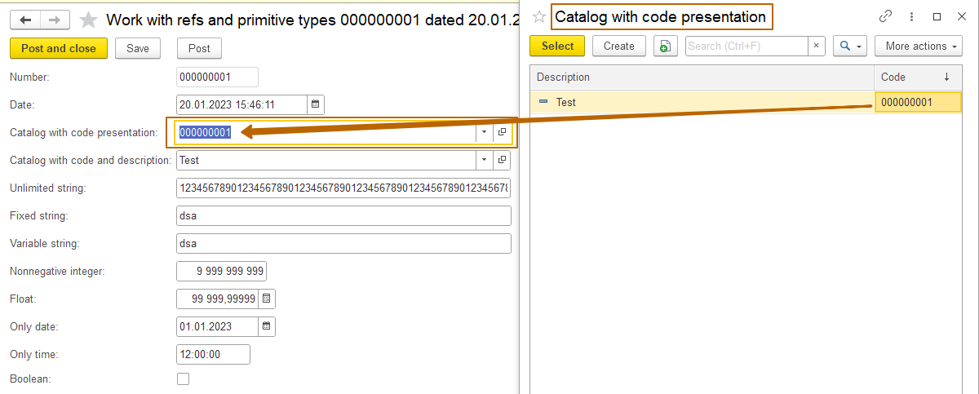

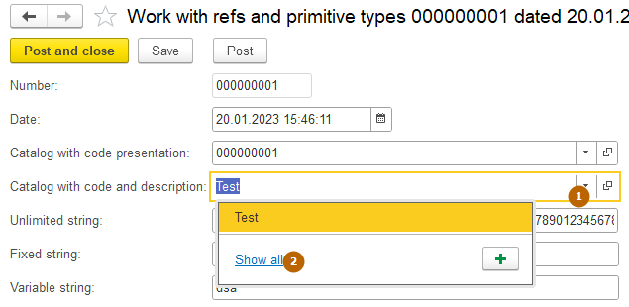
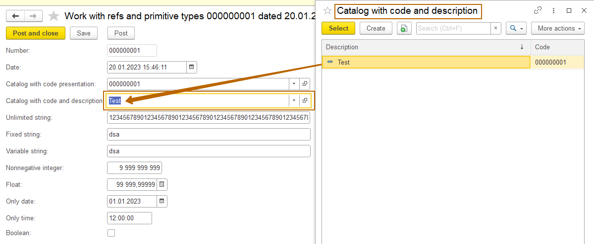
- Fill the attributes with primitive types and compare them with each other:
  - Fixed and variable strings
  - Nonnegative integer and float – both have length of 10, but due to the fact that the “Float” has a fractional part of 5 digits, its integer part is shorter (also 5 digits). Float can have a negative value
  - OnlyDate, OnlyTime and Date (standard attribute of a document)
- Fill the unlimited string with any data. Try to paste some very large text to this field.

Task 2. Preparation for the next lesson
Open “Standard attributes” window for any catalog and document (create new if you don’t have any). Compare it, look at properties of each attribute
